B.C.B.A.

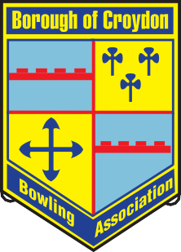

Founded 1935 Year Book 2026
www.bcbabowls.org.uk



CONTENTS PAGE
President’s Message 4
Affiliated Clubs 5
General Purposes Committee 6
Diary Dates 7
Competitions & Rules 8-9
General Rules and Arranging a game 10
Semi-finals 10
Eligibility of Players 10
Substitutes 11
Dress Code 11
Semi-final dates 11
Representative Fixtures 2026 12
Competition Winners 2025 13
Past Presidents 14
Bye-laws 15
Qualifications 15
Representative Games 15
Association Badges 15
Long Service Awards 15
Home Fours – Representative Games 15
Associate of the B.C.B.A. 16
Constitution & Rules 17
Title, Objects & Membership 17
Administration 17-18
Annual and Other General Meetings 18
General Secretary and Treasurer - Duties 18
Council in Appeal 18
Disputes 19
Suspension 19
Life of the Association 19
Alteration and Interpretation of the Constitution and Rules 19
Indemnity Clause 19
Bowls Surrey Regulations 20

President:
Andrew Aldam
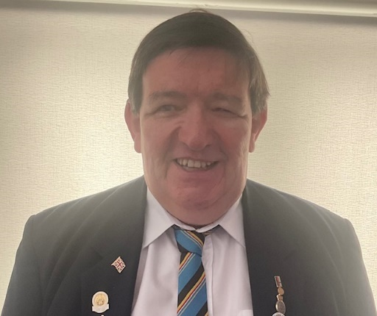
Warlingham Park Bowls Club
Dear Association Member

I am privileged to have been elected to be the B.C.B.A. President for a second year and will again do my upmost to fulfil the role to the best of my ability.

I wish all association members and their clubs every success in all their games and competitions for the 2026 season and look forward to seeing you on the green.

Andrew Aldam
B.C.B.A. President

AFFILIATED CLUBS 2025

Club | Hon. Secretary | Tel:
Ashburton Park | Peter Mason | 020 8656 3696
Bensham Manor | Jorn Cooper | 020 8680 5670
Caterham | Ian Mellis | 07490 484 951
Croydon | Barry Swannie | 07912 502 040
Croydon MO’s | Peter Staples | 07552 109 604
Grangewood | Adrian Staunton | 07341 291 934
New Addington | David Richards | 01689 843 734
Norbury | Merryl D’Souza | 07852 659 002
Norwood Grove | Robert Smith | 07885 627 091
Old Coulsdon | Keith Bishop | 07710 021 701
Purley Bury | Robert Daintree | 07826 949 684
South Norwood Lake | Janet Woods | 07758 081 220
Shirley Park | Jon Whitwell | 020 8777 2253
Spring Park Shirley | Dick Clements | 020 8654 1584
Warlingham Park | John Everest | 01883 624 402

GENERAL PURPOSES COMMITTEE
The General Purposes Committee (GPC) is the body whose task it is to organise and oversee all the various activities of the Association. Its members are elected at the Annual General Meeting of the Association, held in November each year. The GPC consists of the various officers and up to ﬁve general members, all of whom are drawn from clubs aﬃliated to the B.C.B.A.
President: Andrew Aldam (Croydon MO’s.)
40 Harrow Road, Warlingham, Surrey, CR6 9EW
T: 01883 624 616 M: 07792 630 661 Email: signus2011@gmail.com

Vice President: vacant
Hon. General Secretary: Andrew Aldam (Croydon MO’s)

40 Harrow Road, Warlingham, Surrey, CR6 9EW
T: 01883 624 616 Email: signus2011@gmail.com

Asst. General Secretary: Ruth Smith (Croydon MO’s)

M: 07854 583 950

Hon. Treasurer: Colin Gray (Purley Bury)

3 Kaine Place, Shirley, Croydon, CR0 7AH
M: 07934 432 589 Email: colingray2017@gmail.com

Match Secretary: Temporary Andrew Aldam and Ruth Smith
(until position is filled)
Competition Secretary: Peter Mason (Ashburton Park)

T: 020 8656 3696 Email:ashburton.mason@gmx.co.uk
Social Secretary: Peter Mason (Ashburton Park)
T: 020 8656 3696 Email: ashburton.mason@gmx.co.uk
Immediate Past President: Bryan Gonsalves (Croydon MO’s)
General Members:

Fred Blackburn | Tel: 020 8651 2821 | Croydon MO’s
Mike Edwards | Tel: 020 8777 2789 | Spring Park Shirley
Graham McInnes | Tel: 07986 942 801 | Croydon MO’s
Bob Daintree | Tel: 07826 949 684 | Purley Bury
Peter Staples | Tel: 07552 109 604 | Croydon MO’s

DIARY DATES 2026

Spring Council Meeting in 2026 will be on Wednesday 18th March 2026 at 7.00pm. at Purley Bury B.C.

Friday 10th July 2026 Double Fours Final at Croydon MO’s

Thursday 16th July 2026 Hewitts Bowlswear Double Triples Final at Purley Bury BC

Monday 10th to Friday 14th August 2026. Competition Semi-finals.
For individual Dates and times, see the Competition section. (Page 11)

Saturday 5th September 2026 Finals Day at Croydon MO’s

Saturday 26th October 2026 Annual Dinner and Presentation. Venue Purley Bury

Wednesday 11th November 2026 – Annual General Meeting at Purley Bury BC at 7.00pm

Spring Council Meeting in 2027 will be on Wednesday 17th March 2027

COMPETITIONS & RULES

The Following competitions will be held annually unless any unforeseen event arises, with such alterations as from time to time are deemed necessary by the General Purposes Committee (G.P.C.). They are open to all fully paid-up members of the Affiliated Clubs except where specific conditions apply.
Competitions are open to the previous season’s winners of the Singles Championship of each Affiliated Club and the winner of the Championship Singles and Champion of Champions. Players who change clubs between seasons are still eligible. Entry for this competition and qualification under By-Law 1e is available to a player who in any one season entered the Singles Championship of only one Club.
Competitions shall be played in accordance with the current edition of "Laws of The Sport" as published by "Bowls England", except when a specific Rule has been put in place by The Association.
The administration of competition affairs shall be the responsibility of The Competition Secretary whose decision in any dispute shall be final.
Changes to the Competition Rules are determined by the G.P.C. Any proposed alteration to the Competition Rules by an affiliated club must be submitted in writing to the General Secretary of The Association by the Secretary of said club for consideration by the G.P.C.
- Championship Singles. For the “Scratchley Cup”. Runner-Up to receive the “Furby Cup” (21 Shots).
- Singles competition for the “Jubilee Trophy”. Automatic entry to players in the Championship Singles, who play and lose their first round. Walkovers do not count as 1st round games. (21 Shots).
- Unbadged Singles for the “Pickard Trophy”. Only open to players who are not qualified to play in Association matches. (21 Shots) (see By-Laws 1 page 15).
- Officer’s Singles. Open to the following Association Officers: Gen. Sec.: Asst. Gen. Sec: Match Sec.: Comp. Sec.; Asst. Comp. Sec.; Tour Sec.: Social Sec.; Hon. Treasurer, and the Secretary and Treasurer of each affiliated club together with their Match Secretary. (21 Shots).
- Pairs Championship for the “Stacey Cup”. (18 Ends).
- Unbadged Pairs Championship for the “Frank Crow Millennium Trophy”. Open only to players who are not qualified to play in Association matches. (18 Ends). (See By-Laws 1 Page 15).
- Triples Championship for the “Kennard Cup” (18 Ends).
- Fours Championship for the “Scratchley Shield” Each Club may enter a maximum of 4 Rinks. Runners Up to receive “The Goodwin Bowl” (18 Ends).
- Champion of Champions Singles Comp. for "The Master Bakers Shield". (21 Shots).

Team Games
- The Double Fours competition for the "Advertiser Cup"(see separate Rules page 9).
(b) The Hewitt’s Bowlswear Double Triples Competition for the
“Hewitts Bowls Wear Double Triples Trophy" (see separate Rules page 9).

THE DOUBLE FOURS & HEWITT BOWLSWEAR DOUBLE TRIPLES
a. These competitions shall be open to all Affiliated Clubs and shall be contested by two Fours/Triples from each Club. One Four/Triple shall play at home and the other away, starting at 6:00pm, no later than 6:30pm (this includes 30 minutes grace), on the dates determined by The Association. The combined scores of both Fours/Triples shall determine the winner and an extra-end, played on the green of "The Challenger" used to decide the result in the event of the game being tied at the end of normal play when both scores are known by all players.
b. Each competing team must be made up of players from the same Club. Each player having not played for another Affiliated Club, in any competition, in the same season and registered on B.C.B.A. Database.
c. There is no restriction on the number of substitute players which may be used, except that all players must have their details on the B.C.B.A. Database.
To play in the Final a player must have played in at least one
previous round unless special dispensation is granted by the Competition Secretary.
d. The Finals of the competitions shall be played on a green and at a time nominated by The Association when both teams shall play on adjacent rinks. An Umpire, appointed by The Association, shall be in attendance who will acquaint the players with Rules relevant to the occasion.
e. The use of mobile phones to communicate scores between one green and the other is permitted providing that both teams players, Managers and
co-ordinators are made aware of the state of play and a score board is used during the game to show the other venue. Scores to be updated every 5 ends and then every end from 15 to 18 ends.
f. The “Challenger” is always shown as the home team at both venues.

COMPETITION RULES

1: GENERAL RULES
  - 1a: The Competition Secretary shall, in consultation with The President and other Officers, make the draw for all competitions and fix the closing dates for each round. No deviation from the closing date for each round will be permitted except in special circumstances and only at the discretion of The Competition Secretary.
  - 1b: The winners of the competitions shall be entitled to hold the appropriate trophy until its return is requested by the Competition Secretary.
  - 1c: All finalists will receive a plaque to be presented at the Association Dinner, together with the appropriate trophy. For Team Games one plaque per team. If a substitute player is used in a Final, the prize will be awarded to the player substituted or the substitute whoever has played the most games.
  - 1d: The entry fees shall be determined by the G.P.C.

2: ARRANGING A GAME
  - 2a: The first name drawn shall be the "Challenger" who until the semi- final shall have the right to nominate the green. A "Challenger" wishing to nominate a green other than their own must first seek the permission of The Competition Secretary.
  - 2b: The "Challenger" shall offer the opponent three dates. One date must be a weekend. The opponent must accept one of the dates offered within twenty-four hours of receiving the challenge, except preliminary/first rounds when a response is not required until two weeks prior to the round end date.
  - 2c: Ties may be played at any mutually agreed time of day, but no player may be required to play before 6pm, (semi-finals excepted)

3: SEMI-FINALS & FINALS – CLUBS ARE INVITED TO HOST GAMES
  - 3a: Semi-finals and Finals shall be played on greens selected by The G.P.C.
  - 3b: Semi-finals shall be played on fixed dates determined by the Competition Secretary.
  - 3c: All Finals shall be played on the same day, unless the G.P.C. decide otherwise.

4: ELIGIBILITY OF PLAYERS
  - 4a: All competitors must be fully paid-up members of an Affiliated Club and entered on the B.C.B.A. Database.
  - 4b. All members of a Pairs, Triples or Fours team must be members of the same Affiliated Club and entered on the B.C.B.A. Database.
  - 4c. A competitor may only enter the listed Association Competitions from one Affiliated Club, in any one season.
Page 10

5: SUBSTITUTES
- In Pairs, Triples and Fours competitions, only one substitute player may be used throughout the competition provided that the substitute player has not played for another team in the same competition. A substituted player may return to play in later rounds if they have been registered on the B.C.B.A. Database.

6: DRESS CODE
  - The dress code for the Finals shall be Club Attire registered with Bowls England.
  - Registered Club Attire should be worn in all rounds of all competitions subject to the provisions of Bowls England Rule 32.3c. in that club attire must be registered with Bowls Surrey and all the team must be dressed alike.

7: CONDUCT
- Players are expected to always conduct themselves in a manner which does not bring themselves, their Club, or the Association, into disrepute. Any domestic requirement of an Affiliated Club, e.g. “No Running on the Green” must be respected. Any misdemeanour will be investigated by the B.C.B.A. Governing Body.

8: SEMI-FINAL DATES
- The dates of the various competition semi-finals are fixed and will normally commence on the Monday of the second week of August. Any player entering an Association Competition and reaching a Semi-Final will be expected to play on the given day or forfeit the game.
All players must present all previous Team score cards to the
Competition Secretary by 5.00pm with play expected to
commence at 5.30pm.

Dates for 2026 August

Scratchley Fours Monday 10th August 2026
Triples Tuesday 11th August 2026

Officers’ Cup Tuesday 11th August 2026

Championship Singles Wednesday 12th August 2026
Jubilee Singles Wednesday 12th August 2026

Unbadged Pairs Thursday 13th August 2026

Champion of Champions Thursday 13th August 2026
Championship Pairs Friday 14th August 2026

Unbadged Singles Friday 14th August 2026
Page 11

REPRESENTATIVE FIXTURES 2026

M | Date | Opponents | Venue | Time | Meal | Whites  /Greys
 | May.
1 | 10/05/26 | Bellingham | Bellingham | 2.30pm | Y | Greys
 | Jun.
2 | 03/06/26 | Banks B.A. | Croydon MO’s | 2.00pm | Y | Greys
3 | 10/06/26 | Horley | Horley | 2.30pm | N | Greys
4 | 28/06/26 | Croydon MO’s. | Croydon MO’s | 2:30pm. | Y | Greys
 | Jul.
5 | 22/07/26 | B.B.D.B.A.  CANCELLED | Shirley Park | 2.00pm | Y | Greys
6 | 30/07/26 | Sutton & District BA | Croydon MO’s | 2:30pm | Y | Greys
 | Aug.
7 | 09/08/26 | Shirley Park | Shirley Park | 2.00pm | Y | Whites
8 | 19/08/26 | Purley Bury | Purley Bury | 2.00pm | Y | Greys
 | Sept.
9 | 09/09/26 | Civil Service | Croydon B. C. | 2.00pm | Y | Greys
 | Oct.
10 | 18/10/26 | Donyngs IBC | Donyngs IBC | 2.00pm | N | Greys

Association matches are available to all Qualified Players (See By-Law 1) Apply to the General Secretary.

Page 12

COMPETITION WINNERS 2025

Champion of Champions

James Rabson (Purley Bury)

Championship Singles

Richard Lawrence (Caterham)

Pickard Singles

Kevin Clark (Purley Bury)

Jubilee Singles

Tom Ward (Purley Bury)

Officer’s Cup

Bob Daintree (Purley Bury)

Pairs

Peter Pring Jnr (Shirley Park)

Unbadged Pairs

Kevin Clark (Purley Bury)

Triples

Norman Ross (Shirley Park)

Scratchley Fours

Peter Staples (Croydon MOs)

Double Fours

Old Coulsdon

Hewitt’s Bowlswear Double Triples -
Old Coulsdon
President’s Bowl
Spring Park Shirley

Details of ﬁnalists and the results of earlier years can be found on the Borough website at:
http://www.bcbabowls.org.uk
Page 13
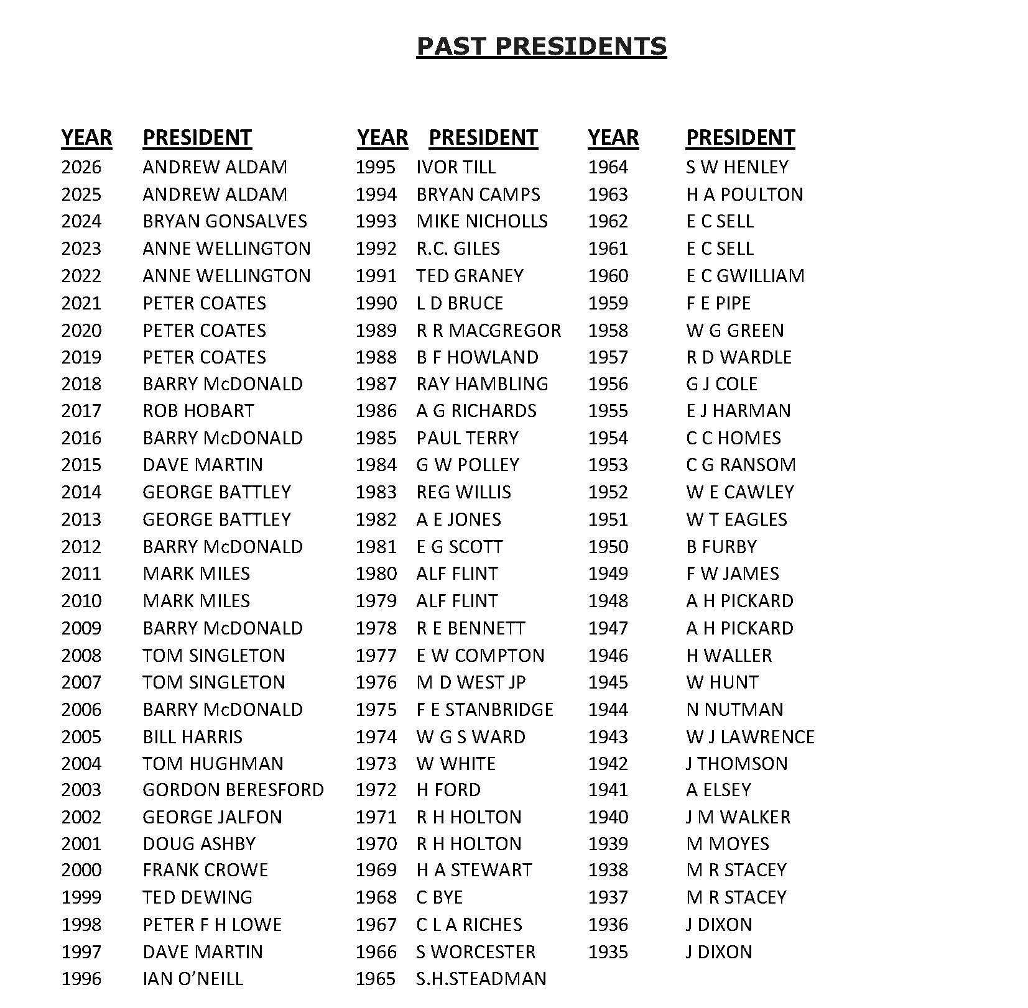

Page 14

BY-LAWS

1: QUALIFICATION
The condition under which any member of an Affiliated Club can play for the Association shall be: -

- 1a: The finalists in all the Association Competitions except the Double Rink and the Hewitt’s Bowlswear Double Triples. (see 1h below)
- 1b: The finalists in Unbadged Pairs, Triples and Rink competitions, must have played in at least one round prior to the Final to be eligible.
- 1c: The Semi-Finalists and Finalists in the Pairs Championship who must have played in at least two rounds prior to the Semi-Finals.
- 1d: The Quarter Finalists of the Singles Championship.
- 1e: In the Unbadged Singles, the two Finalists if the entry is sixteen or less. If the entry exceeds sixteen the four Semi-Finalists.
- 1f: The current Singles Champion(s) of an Affiliated Club.
- 1g: If they are qualified to play for a County.
- 1h: A member of the winning team in the Double Rink or the Hewitt’s Bowlswear Double Triples provided that they have played in every game.
- 1i: If they have been elected to an Office as defined in Rule 4a of the constitution.

REPRESENTATIVE GAMES
- These are the Association matches as shown in the Fixture List each year. “Presidents Games” are not deemed to be “Representative Games”; they do not count towards the games referred to in By-Laws 3 & 4. If a “Representative Game” is cancelled without prior notice, players selected for and attending that game shall be deemed as played.

ASSOCIATION AWARD
- A player who has played in one Representative game is awarded a Baseball Cap or similar displaying the badge of the Association.
- A player who has played Twenty Representative Games is awarded the Gold Shirt Flash of the Association.

LONG SERVICE AWARDS
- A player who has played in one hundred Representative Games shall be awarded a plaque or other suitable trophy, together with a “B.C.B.A. 100 Games” Gold Shirt Flash. The completion of two hundred and any subsequent hundred games will be similarly rewarded.

5. HOME FOURS
- When a "Representative Game" is played on the green of an Affiliated Club, that Club shall have the privilege of nominating one four to play in the match. The players selected must be "Qualified" (see By-Law 1) and such games will count towards the awards in By-Laws 3 & 4.

Page 15

6. ASSOCIATE OF THE B.C.B.A.
- Any qualified member who ceases to play for an Association club immediately loses all rights and privileges they had as an Association member, as previously detailed under these By-Laws and elsewhere under the Constitution & Rules.
- Former members who had received their Gold Wire Badge / Gold Shirt Flash for playing 20 games may, however, request to be considered as an Associate of the B.C.B.A. and if accepted as such by the G.P.C. may be invited to play as a 'Guest' for the Association from time to time at the discretion of the Selection Committee of the G.P.C.

- Such 'Guest' appearances do not confer any other rights and may not be at the expense of any Association applicant of similar playing ability. These restrictions do not apply to B.C.B.A. Past Presidents.

- In the event of a representative game not being fully supported
by qualified players the Selection Committee can select unqualified
players from within the B.C.B.A. but not at the expense of a
qualified player.
Page 16

CONSTITUTION & RULES
1. TITLE
The Association shall be called the "Borough of Croydon
Bowling Association”. (BCBA)

2: OBJECTS
a) To promote, foster and safeguard the level green game
of bowls in Croydon.
b) To hold annual and other championships.
c) To organise competitions, tournaments, inter Association games
and other such games as the General Purposes Committee
may approve. (GPC).

3: MEMBERSHIP
- Membership of The Association shall be open to all Clubs whose headquarters, at the time of application is situated in the area controlled by The London Borough of Croydon or whose club house is allocated a "CR" postcode and are affiliated to Bowls Surrey and whose application is approved by the GPC.
- Application by Clubs for admission to The Association shall be made to The General Secretary in writing and must be accompanied by a list of Office bearers and the address of the Club Secretary and the address of the green.
- The Annual Subscription for membership shall be determined at the Annual General Meeting and payable not later than the closing date for competition entries in each year. Any Club failing to make this payment shall forfeit all rights and privileges of membership so long as such fee remains unpaid.

4: ADMINISTRATION
a) The over-all affairs of The Association shall be managed by a
Committee consisting of:-
The President, Vice-President, General Secretary, Asst.
Gen. Secretary, Hon. Treasurer, Match Secretary,
Competition Secretary, Asst. Comp. Secretary, and Social Secretary,
hereinafter called the Officers,
elected at the Annual General Meeting (AGM).
Together with the immediate President and one vote from each
Affiliated Club.

b) The day-to-day affairs of The Association shall be conducted by a
GPC consisting of the Officers together with the Immediate
Past President and up to five members to be elected at
the AGM.
c) General Meetings of the Association maybe convened by the GPC
whenever in its opinion, it has determined sufficient cause exists.
An Extraordinary General Meeting (EGM) must be held within
28 days of the requisition of any 3 Affiliated clubs to consider
the business or grievance set forth in the requisition.
Page 17
d) This requisition must clearly state the nature of the matter
at issue and must be signed by at least 2 officers of each club.
The Notice calling such a meeting shall state the purpose for which
it was requisitioned.

5. ANNUAL AND OTHER GENERAL MEETINGS

a) The AGM of the Association shall be held in the month of November each year. Twenty-one days’ notice of it and every other General Meeting shall be given and ten members of Affiliated Clubs, with voting powers shall form a quorum.
b) At these meetings, all Officers and Past Presidents of the Association shall be entitled to vote and every Affiliated Club shall be entitled to one vote. Other members of Affiliated Clubs are entitled to attend these meetings and may participate in the discussions but shall have no voting power.

c) General meetings of The Association maybe convened by the GPC whenever in its opinion it has determined that sufficient cause exists. An EGM must be held within twenty-eight days of the requisition of any three Affiliated Clubs to consider the business or grievance set forth in the requisition.

d.) This requisition must clearly state the nature of the matter at issue and be signed by at least two Officers of each Club. The Notice calling such a meeting shall state the purpose for which it was requisitioned.

6. THE HON. TREASURER AND GENERAL SECRETARY

The Hon. Treasurer shall render to the AGM an account of the income and expenditure for the past financial year, audited and signed by one competent person who shall not be a member of the GPC and who shall have been elected at the previous AGM.
The General Secretary shall cause a record to be kept of all the business transacted at the AGM and other GPC meetings and shall submit to the AGM a report of activities of the Association since the previous AGM.
Copies of the Annual Report and Statement of Accounts shall be sent to every Affiliated Club before the AGM.

7. THE COUNCIL IN APPEAL

The GPC shall be empowered to adjudicate upon any dispute referred to it, arising between or among Affiliated Clubs, or any member thereof or any practice or policy or complaint which it shall hold to be in its jurisdiction. The subject of reference or appeal must be stated in writing to the General Secretary who, after reporting the same to the GPC, shall call either a Special Meeting of the GPC to discuss it or postpone its consideration until the next Ordinary GPC Meeting. Parties on each side maybe heard and the decisions of the GPC shall be binding subject to rule 7. It shall be competent for the GPC, after due investigation of the facts and if need be, the examination of witnesses and relevant documentary evidence, to suspend or determine the membership of any Club
Page 18

8. DISPUTE
Any member club shall have the right to appeal to the Association in AGM, against an adverse decision by the GPC on any point provided the appeal be signed by the Club’s Officer Bearers and lodged with the General Secretary of the Association within twenty-one days of the GPC’s decision. Such appeal shall state the grounds on which it is made.

9 SUSPENSION
All Affiliated Clubs and members thereof shall be under the jurisdiction of the GPC in Competitions held by the Association and must conform to the various Rules. In the event of any breach thereof, the GPC shall have the power, after enquiry, to suspend the Club or individual member(s) thereof from the Association’s competitions for such period as they may deem proper.

10. LIFE OF THE ASSOCIATION
The Association shall exist so long as at least eight Clubs continue to carry on its objectives. In the event of all Clubs except one having withdrawn or refusing to carry on the objects of the Association, the property and funds shall be held in trust by that Club for the objects of The Association.

11. ALTERATION AND INTERPRETATION OF THE CONSTITUTION & RULES
No alteration of or addition to the Association Constitution & Rules may be made, except at the AGM of the Association or at a Special General Meeting called for that purpose and any such alteration or addition must receive at least two thirds of the votes cast. Intimation of any proposed alteration or addition shall be given in writing to the General Secretary not later than the thirtieth of September and shall be specified in the notice convening the meeting, of which twenty-one days’ notice shall be given. Any alteration or addition shall be duly intimated by the General Secretary to the Secretaries of all the Affiliated Clubs.
When in doubt as to the correct interpretation of any part of the Constitution & Rules, or in the event of a point arising, not covered herein, the Rules of Bowls Surrey shall be applied and if a point arises not covered by the County Rules, the matter shall be referred to Bowls England whose decision, in every case, shall be final.

12. Any BCBA/GPC Officer and/or its sub-committees shall be indemnified by the BCBA against all costs and losses which he/she may incur or sustain in relation to the execution of the duties of his/her office, or by reason of any duty performed for or with the authority of the GPC, only up to the limit of the bank balances of the Association."

Page 19

BOWLS SURREY REGULATIONS

Bowls Surrey Regs 2.5.1 The date of the affiliation year has now formally been changed to 1 May. The Regulation stipulates that the affiliation process should continue throughout the season with a final top-up on 1 September.
Requirement for Clubs and Members to adopt and follow BE Regulations. Regulation 2.5 2 (detailed below) now says this about the mandatory requirements that must be included in all clubs’ constitutions:
Bowls Surrey Regs 2.5.2 All clubs and county associations, must as a qualification
of membership adopt and follow:
  - All policies and guidelines approved by Bowls England. Including but not limited to, safeguarding policies, inclusion policies and anti-doping policies.
  - All procedures set out in Bowls England Regulation 9, 9A and 9B when dealing with any disciplinary/misconduct issues.
  - All members shall be deemed to have made themselves familiar with and agreed to be bound by the UK Anti-Doping Rules and to submit to the authority of UK Anti- Doping in the application and enforcement of the Anti-Doping Rules. The UK Anti- Doping Rules apply to all members participating in the sport of Lawn Bowls for a minimum of 12 months from the commencement of membership, in accordance with Bowls England’s Rules & Regulations whether the member is a citizen of, or resident in, the UK.
  - All sanctions, recommendations and/or decisions from the Case Management Panel or National Disciplinary Panel.

These requirements shall be included in all Club and

County Constitutions.”
Note. The “Case Management Panel” is a reference to the Safeguarding
Case Management Panel. Clubs should now update their constitution/rules
to add new requirements i.e. anti-doping, to ensure conformity.

A full copy of all Bowls Surrey and Bowls England policies are held by the BCBA General Secretary.
Page 20



Page 21

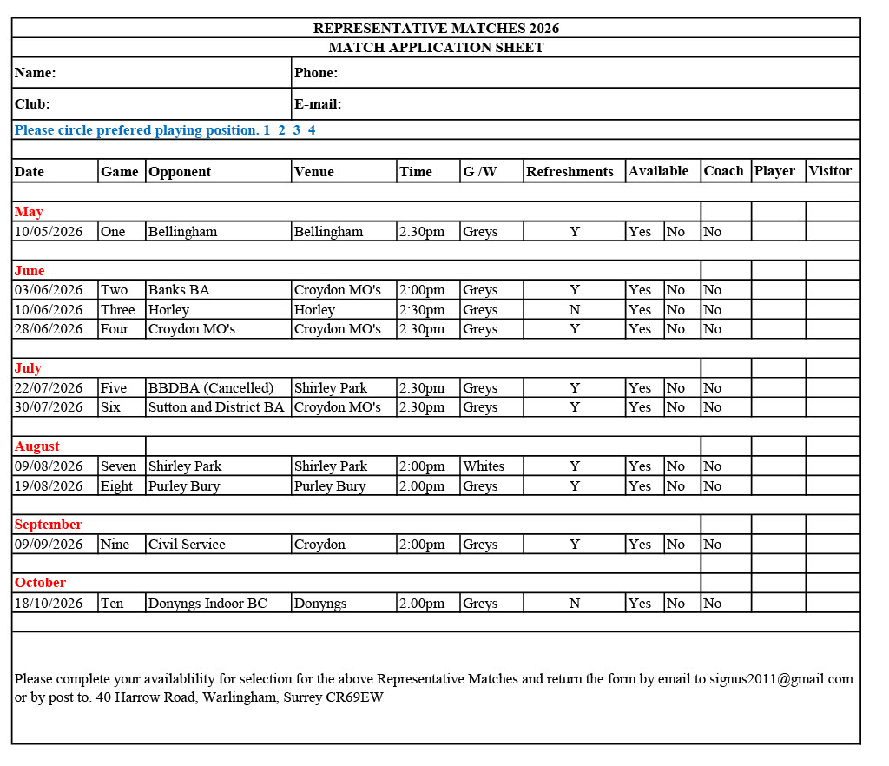
Page 22
Page 23

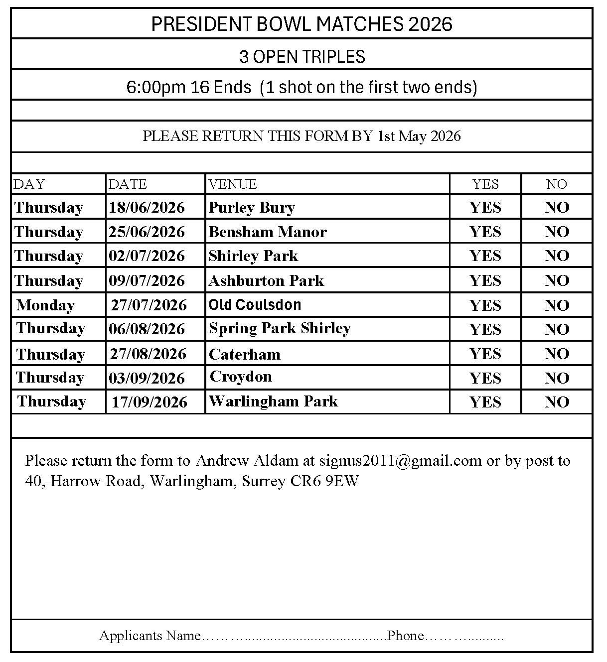
Day | Date | Competition | Venue | Contact Details Mobile / Home | E-mail | Confirmed
Page 24
Appendix A
Guidelines for Competition Secretaries on receipt of a complain of an unfit rink. These guidelines are solely concerned with a game in progress. Under Rule 7.5 of the Competition Rules and Regulations All protests about the condition and fitness of a green must be made before the commencement of the sixth end of a game. The playing of the game must cease and the Competition Secretary contacted immediately, either directly by phone or text. The Guidelines for competition Secretaries (Appendix A) will come into operation to determine the outcome.
The Competition Secretary (or representative) will inspect the green within 24 hours. If the Competition Secretary (or representative) certifies that the green is unfit for play the home club will be informed immediately and arrangements will be made for the game to be played on the opponent’s green at the discretion of the Competition Secretary. Should the Competition Secretary (or representative) certify the green fit to play, the game must be resumed from the point it ceased. Should play continue other than on the original day. Trial ends will be permitted. The decision of the Competition Secretary (or representative) relating to all protests under this rule shall be final and binding on all competitions concerned. Actions to be taken by the Competition Secretary.
- On receipt of a complaint either directly from a player or the competition secretary the secretary must attend the venue as soon as possible or if unable to attend arrange for a replacement to attend. 9 BS Competition Rules as amended 12th January 2024
- The Secretary shall familiarise Him / Herself with the details of the complaint and after visually assessing the rink, bowl to a short, medium and long jack on both hands.
- He / She shall note the consistency of the draw or lack thereof, at least two bowls on each hand to the stated length shall be bowled.
- If in the opinion of the Secretary the rink is of the standard to permit fair competition play will continue as dictated in the rule (see above)
- The matter will then be closed: no appeal will be allowed.
- If the opinion is that the rink is not fit, rule 7.5 (see Above) will operate. If the game cannot be decided as set out above, then arrangements must be made for the game to be completed before the date of the following round.
- GREENS.
  - games shall be played only upon greens with a suitable playing surface which shall be level and of at least 31 metres in length, exclusive of banks and ditches. The (GPC) shall have the power to inspect any green to ensure suitability.
  - Where the green chosen by the challenger, as drawn, does not conform with Rule 7.1 and where the green of the opponent, as drawn, does conform with the said Rule, the game shall be played on the opponent’s green and he/she shall become the challenger, for the purpose of the game.
  - Where the greens of both competitors do not conform with Rule 7.1, the game shall be played on a neutral green by mutual arrangements.
  - and 7.5 Outdoor Synthetic Surfaces are acceptable provided it conforms to Rule 7.1
All protests about the condition and fitness of the green, must be made before the commencement of the sixth end of the game. The playing of the game must cease and the Competition Secretary contacted immediately, either directly by phone or text. The Guidelines for competition Secretaries (Appendix A) will come into operation to determine the outcome. The Competition Secretary (or representative) will inspect the green within 24 hours. If the Competition Secretary (or representative) certifies that the green is unfit for play the home club will be informed immediately and arrangements will be made for the game to be played on the opponent’s green at the discretion of the Competition Secretary. Should the Competition Secretary (or representative) certify the green fit to play, the game must be resumed from the point it ceased. Should play continue other than on the original day. Trial ends will be permitted. The decision of the Competition Secretary (or representative) relating to all protests under this rule shall be final and binding on all competitions concerned. Actions to be taken by the Competition Secretary.

  - Competitor’s may not smoke on or within 1 meter (3’3”) of the green whilst playing a County Championship or Competition (This includes electronic cigarettes).
  - The use of electronic devices (including Mobile Phone on the green
is prohibited during all games.)

